Linux Lab Assignment (Internal)

Q1. Directory and File Management
Create a main directory using your Name_RollNo format. Example: Rajesh_23010101 Inside it perform the following:
a) Create subdirectories: Docs, Programs, Backup
b) Inside Docs, create files: exp1.txt, exp2.txt
c) Copy exp1.txt into Backup
d) Rename exp2.txt to labrecord.txt
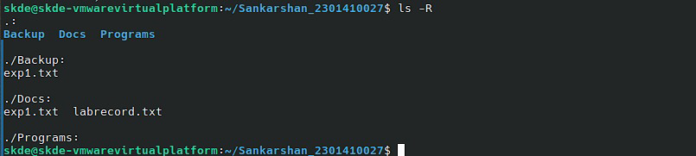
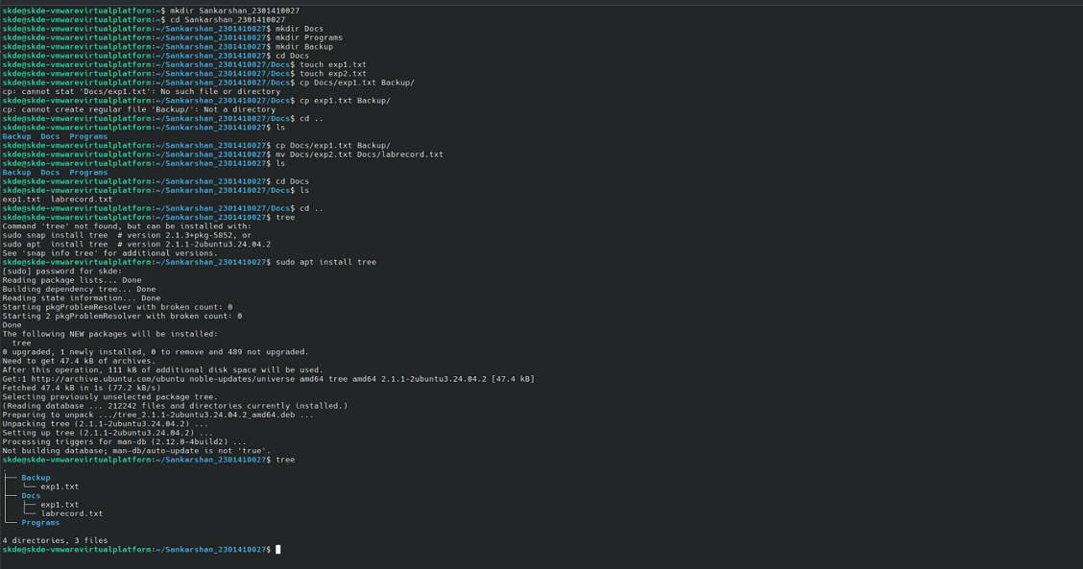
e) Show complete directory structure using command.
Q2. Shell Script Writing
Create a shell script named: scriptA_RollNo.sh Write script to:
a) Accept student name as input
b) Display Welcome message with name
c) Display current date and time
d) Display present working directory
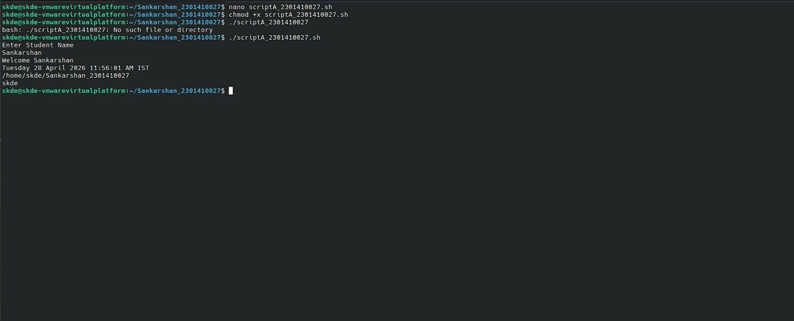
e) Display logged in username Run the script successfully.
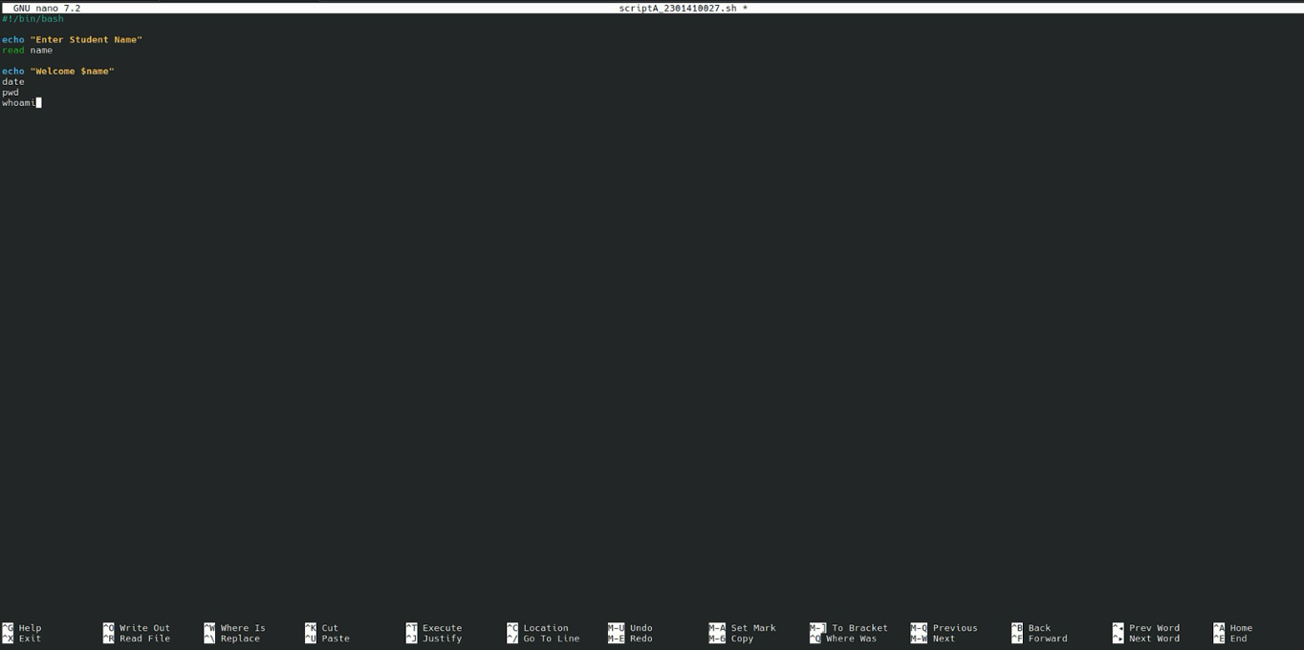
Q3. Permissions & Text Commands
Inside your main directory:
a) Create file data_RollNo.txt
b) Give only owner read/write permission
c) Write any 5 Linux commands in file
d) Display file contents
e) Count total lines in file
